EXPERIMENT 2 :- THRESHOLD FREQUENCY = 40

--------------- **RAINFALL NORMALISED | LINEAR KERNEL FUNCTION**  ---------------

|  |  |  |  |
| --- | --- | --- | --- |
| **INPUT** | | **MODEL** | |
| TRAINING SET | CONCATENATED INSTANCES FROM 1 TO 3904 AND FROM 2 TO 3905 OF EXTMAT | SUPPORT VECTOR MACHINE REGRESSION MODEL | |
| TARGET FOR THE TRAINING SET | INSTANCES FROM 3 TO 3906 OF rain_mum_1969_2007_1grid_norm | TRAINING | * mdl5 = fitrsvm(E3,P) * Trained using the predictor values in the matrix E3 and the response values in the vector P * E3[3904 x 3190]=instances from 1 to 3904 and from 2 to 3905 of EXTMAT * P[3904 x 1]=instances from 3 to 3906 of rain_mum_1969_2007_1grid_norm |
| TEST SET | CONCATENATED INSTANCES FROM 3905 TO 4756 AND FROM 3906 TO 4757 OF EXTMAT | PREDICTING | * yfit5 = predict(mdl5,Ep3) * Ep3 is the Test set * Ep3[852 x 3190]=instances from 3905 to 4755 and 3906 to 4756 of EXTMAT |
| TARGET FOR THE TEST SET | INSTANCES FROM 3907 TO 4758 OF rain_mum_1969_2007_1grid_norm | TESTING | * err5= immse(yfit5,Pp) = **0.0509** * err5 is the Mean Square Error * yfit5[852 x 1]=predicted values on the Test set * Pp[852 x 1]=instances from 3907 to 4758 of rain_mum_1969_2007_1grid_norm |

PLOTTING : plot(yfit5,'r')

hold on;

plot(Pp,'g')

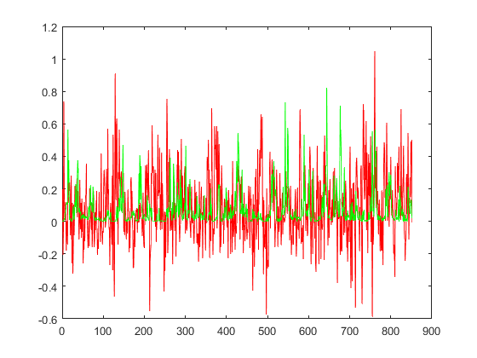

--------------- **RAINFALL NORMALISED | GAUSSIAN KERNEL FUNCTION**  ---------------

|  |  |  |  |
| --- | --- | --- | --- |
| **INPUT** | | **MODEL** | |
| TRAINING SET | CONCATENATED INSTANCES FROM 1 TO 3904 AND FROM 2 TO 3905 OF EXTMAT | SUPPORT VECTOR MACHINE REGRESSION MODEL | |
| TARGET FOR THE TRAINING SET | INSTANCES FROM 3 TO 3906 OF rain_mum_1969_2007_1grid_norm | TRAINING | * mdl6 = fitrsvm(E3,P,’KernelFunction’,’gaussian’) * Trained using the predictor values in the matrix E3 and the response values in the vector P * E3[3904 x 3190]=instances from 1 to 3904 and from 2 to 3905 of EXTMAT * P[3904 x 1]=instances from 3 to 3906 of rain_mum_1969_2007_1grid_norm |
| TEST SET | CONCATENATED INSTANCES FROM 3905 TO 4756 AND FROM 3906 TO 4757 OF EXTMAT | PREDICTING | * yfit6 = predict(mdl6,Ep3) * Ep3 is the Test set * Ep3[852 x 3190]=instances from 3905 to 4756 and 3906 to 4757 of EXTMAT |
| TARGET FOR THE TEST SET | INSTANCES FROM 3907 TO 4758 OF rain_mum_1969_2007_1grid_norm | TESTING | * err6= immse(yfit6,Pp) = **0.0122** * err6 is the Mean Square Error * yfit6[852 x 1]=predicted values on the Test set * Pp[852 x 1]=instances from 3907 to 4758 of rain_mum_1969_2007_1grid_norm |

PLOTTING : plot(yfit6,'r')

hold on;

plot(Pp,'g')

